Target journal: **Frontiers in Marine Science**

– Research Topic on **“Research and Management of Eutrophication in Coastal Ecosystems”**

**Past, present and future eutrophication status of the Baltic Sea**

*Ciaran Murray1*, Bärbel Müller-Karulis2,3, Jacob Carstensen4,5,*

*Daniel Conley6, Bo Gustafson2,3 and Jesper H. Andersen1*

*1 NIVA Denmark Water Research, Copenhagen, Denmark*

*2 Stockholm University, Stockholm, Sweden*

*3 Baltic Nest Institute, Stockholm, Sweden*

*4 Aarhus University, Roskilde, Denmark*

*5 Baltic Nest Institute Denmark, Roskilde, Denmark*

*6 Lund University, Lund, Sweden*

***\*Correspondence:***[cjm@niva-dk.dk](mailto:cjm@niva-dk.dk)

We model and assess the past, present and predicted future eutrophication status of the Baltic Sea. The assessment covers a 350-year period from 1850 to 2200 and is based on: (1) input scenarios for nitrogen and phosphorus, (2) modelling of concentrations of dissolved inorganic nitrogen (DIN), dissolved inorganic phosphorous (DIP), chlorophyll-a, Secchi depth, and oxygen, and (3) the application of a multi-metric indicator-based tool for assessment of eutrophication status, i.e. HEAT 3.0. Our study reveals significant changes in eutrophication status from 1850 to 2200 in most Baltic Sea basins. The change from a healthy state without eutrophication problems in the open parts of the Baltic Sea took place in the late 1950s and early 1960s. In some basins, recovery began in the late 1990s, whilst in other it commenced just after the turn of the century. Based on model results, we expect that the first basin to achieve a status without eutrophication will be Arkona, in 2033. By 2060-2070, a status without eutrophication will also be seen in the Kattegat, Bornholm Basin and Gulf of Finland, followed by the Danish straits around 2088. For the Baltic Proper and Bothnian Sea, a good status with regard to eutrophication can be expected in 2200, or later. Further, we conclude that not all basins are likely to meet the targets agreed upon and to attain a status unaffected by eutrophication, i.e. the Gulf of Riga and Bothnian Bay. These results, especially the prediction that some basins will not achieve a good status, can be used in support of continuous development and implementation of the regional ecosystem-based nutrient management strategy, the HELCOM Baltic Sea Action Plan.

**Keywords: eutrophication, Baltic Sea, nutrient loads, modelling, scenarios, integrated assessment, status classification**

*Submitted:* XX xxxxxx 2018

**INTRODUCTION**

The causes, process and effects of nutrient enrichment and eutrophication in the Baltic Sea are well understood and well documented (Larsson et al., 1985; Rönnberg et al., 2004; Vahtera et al., 2007; Andersen et al., 2011; Fleming-Lehtinen et al., 2015). There is no commonly agreed definition of eutrophication, but there is a conceptual understanding what the consequences of nutrient enrichment are (Andersen et al., 2006; HELCOM, 2009). Discharges, losses and inputs of nutrients from upstream catchments, atmosphere, neighbouring sea (i.e. the North Sea) and sediment pools lead to elevated concentration of nutrients in seawater. In most parts of the Baltic Sea, the direct consequences of elevated nutrient concentrations are increased production of phytoplankton (Richardson & Heilmann, 1995; Wasmund et al., 2008), in some areas manifested as blue-green algal blooms (Finni et al. ,2001). The increased production of organic matter has indirect consequences in most parts of the Baltic Sea. The release of nutrients from sediments leads to significantly reduced oxygen concentrations and hypoxia is a large-scale problem (Conley et al., 2011; Carstensen et al., 2014). Subsequently, reduced oxygen concentrations have affected not only benthic invertebrates (Villnäs and Norkko, 200x) but also the spawning success of cod, a commercially important fish species (MacKenzie et al., 2000; Köster et al., 2001). The remineralisation and flux of phosphorus from seabed sediment to surface waters is a crucially important indirect effect of eutrophication (Vahtera et al., 2007), creating a vicious circle where the eutrophication process is self-reinforcing.

Baltic Sea states have worked for decades to reduce inputs and improve eutrophication status, primarily under the umbrella of the Helsinki Convention on the Protection of the Marine Environment of the Baltic Sea Area, often referred to as the Helsinki Convention, or in short HELCOM. With the adoption of the Baltic Sea Action Plan (BSAP) in 2007 (HELCOM, 2007, Backer et al. 2010), this work turned into a new phase being based on numerical target values and model calculations for basin-wise Maximum Allowable Inputs and Country-wise Allocated Reduction Targets.

With the 2013 update of the BSAP’s eutrophication segment, the Baltic Sea States not only implement the Ecosystem Approach to management of human activities but also set a new standard for the development of an adaptive and evidence-based nutrient management strategy (HELCOM 2013a). The end target for the BSAP is to attain, in 2020, a healthy Baltic Sea unaffected by eutrophication, including (1) concentrations of nutrients close to natural levels, (2) clear water, (3) natural levels of algae blooms, (4) natural distribution and occurrence of plants and animals, and (5) natural oxygen levels.

The objectives of this study are: (1) to use model results to classify eutrophication status of nine Baltic Sea basins for the period 1850-2200, (2) to identify the basins which are likely to see improvement to a status not affected by eutrophication, and those basins which are not expected to achieve this status.

**METHODS**

This study represents a meeting of two processes: (1) the regular assessment of eutrophication status in the Baltic Sea region using indicator-based eutrophication assessment tools (i.e. the HEAT tool), and (2) the implementation of the BSAP, particularly the expected future reduction in nutrient inputs from land-based sources and the atmosphere.

**Study Area**

The Baltic Sea is an inland sea in northern Europe surrounded by Sweden, Finland, Russia, Estonia, Latvia, Lithuania, Poland, Germany and Denmark and with a surface area of 415,200 km2 (Table 1). The Baltic Sea is usually divided into several basins separated by sills, including a transition zone to the North Sea entailing the Kattegat and the Danish Straits (**Figure 1, Table 1**).

The basins vary substantially regarding ice cover, temperature, salinity, maximum depth and residence times. The composition of the biota, both below and above water surface, changes strongly along these gradients. More information about Baltic Sea characteristics can be found in Bonsdorff (2006), Johannesson and André (2006), Österblom et al. (2007), and Leppäranta and Myrberg (2009). Nutrient enrichment and eutrophication signals within the study area are very well studied and documented (HELCOM, 2009; Andersen et al., 2011; Carstensen et al., 2014; Fleming-Lehtinen et al., 2015). The root causes and inputs and fluxes of nitrogen and phosphorus are in general well understood and documented (HELCOM, 2015; Vahtera et al., 2007).

Actions to improve the ecosystem health of the Baltic Sea, including the currently impaired status regarding eutrophication, are under way (Baltic Sea Action Plan (HELCOM, 2007) and EU Marine Strategy Framework Directive (Anon., 2008). With the most recent update of the Baltic Sea Action Plan, the countries bordering the Baltic Sea have – in the context of the eutrophication segment of the plan – agreed on a fully-fledged ecosystem-based nutrient management strategy (Anon., 2013).

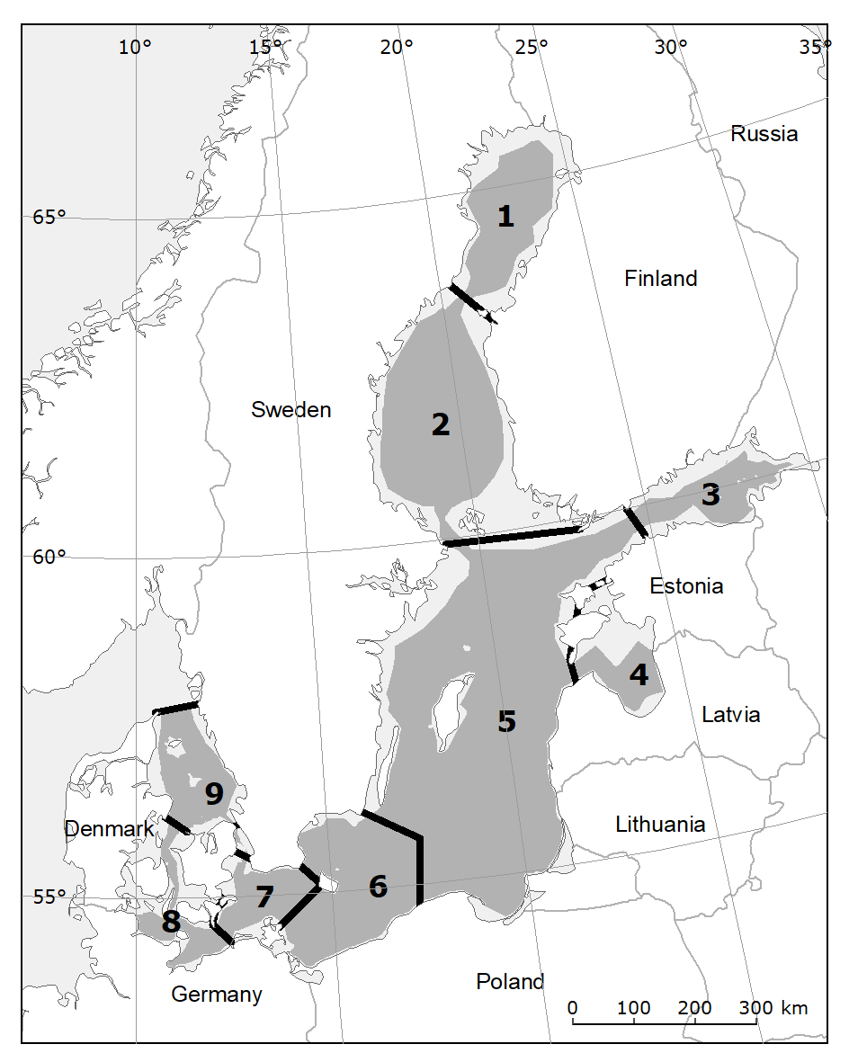

**FIGURE 1** **Map of the Baltic Sea**. The numbers 1 to 9 identify the basins, as shown in **Table 1** below. The darker shading indicates the open water parts of the subdivisions. The BALTSEM model simulations conditions in the open parts, not including coastal waters.

**TABLE 1 Key characteristic of the Baltic Sea and the nine assessments units in this study**. Based on Andersen et al. (2015) and Fleming Lehtinen et al. (2015).

|  |  |  |  |  |  |  |  |
| --- | --- | --- | --- | --- | --- | --- | --- |
| **ID** | **Basin** | **Area** | **Max depth** | **Avg. depth** | **Surface salinity** | **N input** | **TP input** |
|  |  | km2 | m | m | PSU | t yr-1 | t yr-1 |
| 1 | Bothnian Bay | 33,232 | 127 | 41 | 1.8–3.9 | 55,780 | 2,580 |
| 2 | Bothnian Sea | 83,908 | 270 | 55 | 3.8–6.6 | 74,530 | 2,660 |
| 3 | Gulf of Finland | 29,911 | 123 | 34 | 1.2–5.6 | 125,050 | 6,810 |
| 4 | Gulf of Riga | 18,797 | 53 | 22 | 4.1–6.2 | 89,060 | 2,810 |
| 5 | Baltic Proper | 149,697 | 459 | 71 | 5.0–7.5 |  |  |
| 6 | Bornholm Basin | 42,161 | 100 | 44 | 4.3–8.1 | 413,680 | 16,510 |
| 7 | Arkona Basin | 16,405 | 50 | 25 | 7.6–11.3 |  |  |
| 8 | Danish Straits | 21,022 | 50 | 14 | 6.9–22.9 | 53,970 | 1,470 |
| 9 | Kattegat | 23,557 | 120 | 22 | 12.2–30.2 | 69,170 | 1,550 |
| Total |  | 418,690 | 459 | 51 | 1.2–30.2 | 881,240 | 34,390 |

**Data Sources**

The Baltic sea Long-Term large-Scale Eutrophication Model (BALTSEM: Gustafsson et al., 2012; Savchuk et al., 2012) is a coupled physical-biogeochemical model of the Baltic Sea. It represents its complex topography with linked 1D models, that represent 13 basins with high vertical resolution. The BALTSEM setup used describes the dynamics of nitrogen, phosphorus and silica. These nutrients are taken up by three groups of phytoplankton for growth and are regenerated by heterotroph organisms in the water column. Detritus groups corresponding to each nutrient transport nutrients into the bottom sediments, whose slow remineralization provides a long-term memory for past nutrient inputs. Oxygen consumption is coupled to all mineralization processes. BALTSEM has been extensively validated against field data and other models (Eilola et al., 2011; Savchuk et al., 2012). It has been used to simulate the change in ecological indicators (Meier et al., 2012; Neumann et al., 2012) and was applied to calculate the Maximum Allowable Inputs of nutrients to the Baltic Sea in the revision of the Baltic Sea Action plan (HELCOM, 2013b).

The past eutrophication status of the Baltic Sea in 1850–2006 was simulated by forcing the BALTSEM model with reconstructed nutrient inputs and atmospheric conditions as described in Gustafsson et al. (2012). Its future status was then assessed by extending the model runs for another 194 years with different nutrient loads, while hydrodynamics were driven by a statistical representation of present climate. Load scenarios simulate present nutrient inputs, as well as declining and increasing nutrient loads. “Present” inputs (PLC5.5) correspond to the loads observed in the BSAP reference period 1997 – 2003 as described in the review of the 5th HELCOM Pollution Load Compilation (HELCOM, 2013c). Load reductions simulate nutrient inputs according to the 2013 update of the BSAP’s eutrophication segment, implemented either instantaneously (BSAP 2013) or with a linear decrease in loads over 30 years (BSAP 2013t). Further, a high nutrient input scenario (BAUt) mimics intensified agriculture in the Eastern Baltic States (Hägg et al., 2013; Meier et al., 2011) with a 30 year transition from present inputs. The scenarios 1-4 are summarized in Table 2. Details about the scenarios and modelled trajectories for the parameters used as indicators can be found as Supplementary Material.

**FIGURE 2**  **Overview of the scenarios 1-4**. Based on the inputs in the 4 scenarios, nutrient inputs and subsequent key eutrophication signals have been modelled for the period 1850-2200.

|  |  |  |  |  |
| --- | --- | --- | --- | --- |
| **No.** | **Name** | **Type** | **Description** | **Temporal trends** |
| 1 | BSAP |  | Baltic Sea Action Plan – instant implementation of load reductions (2007) |  |
| 2 | BSAP30 |  | Baltic Sea Action Plan – linear reduction over 30 years (2007-2027) |  |
| 3 | PLC55 |  | Constant loads as for BSAP reference period (1997-2003) |  |
| 4 | BAU30 |  | Increasing loads over 30 years (agricultural intensification in E. Baltic) |  |

**HEAT 3.0**

In this study, we apply the recent version of the HELCOM Eutrophication Assessment Tools (HEAT 3.0), which has been used for assessing eutrophication in the Baltic Sea for the periods 2007-2011 (Fleming-Lehtinen et al., 2015) and 1901-2012 (Andersen et al., 2017).

For a detailed description of the assessment principles and methods, please confer with the above references including the Supplementary Material to these. Additional information on the development process and earlier versions can be found in Andersen et al. (2010, 2011, 2014) and Fleming-Lehtinen et al. (2015).

The target values applied in HEAT 3.0, for the indicators DIN, DIP, Chl-a, Secchi depth, oxygen debt, are taken from Fleming-Lehtinen et al. (2015). An overview of these values, which are identical to those applied by the study of temporal trends in eutrophication status of the Baltic Sea 1901-2012 (Andersen et al., 2017), is given in Table 2.

**TABLE 2 Basin-specific target values**. Indicators are winter mean concentration of total inorganic nitrogen (DIN), winter mean concentration of total inorganic phosphorus concentrations (DIP), summer mean concentration of chlorophyll-a (Chl-a), summer mean Secchi depth corrected for CDOM (Secchi) and oxygen debt (Oxygen). From Andersen et al. (2017).

|  |  |  |  |  |  |
| --- | --- | --- | --- | --- | --- |
| **Basin** | **DIN** | **DIP** | **Chl-a** | **Secchi** | **Oxygen** |
|  | µM | µM | µg L-1 | m | mg L-1 |
| 1. Bothnian Bay | 5.2 | 0.07 | 2.0 | 5.8 | - |
| 1. Bothnian Sea | 2.8 | 0.19 | 1,5 | 6.8 | - |
| 1. Gulf of Finland | 3.8 | 0.65 | 2.0 | 5.5 | 8.7 |
| 1. Gulf of Riga | 5.2 | 0.41 | 2.7 | 5.0 | - |
| 1. Baltic Proper | 2.5 | 0.29 | 1.6 | 7.7 | 8.7 |
| 1. Bornholm Basin | 2.5 | 0.3 | 1.8 | 6.9 | 6.4 |
| 1. Arkona Basin | 2.9 | 0.36 | 1.8 | 7.2 | - |
| 1. Danish Straits | 4.6 | 0.53 | 1.6 | 8.0 | - |
| 1. Kattegat | 5.0 | 0.49 | 1.5 | 7.6 | - |

**RESULTS**

We report long-term temporal and spatial trends in eutrophication status of the Baltic Sea obtained by taking data originating from modelling and applying the HEAT tool to these model results.

As a first step, we compared the HEAT classifications for the period 1901-2012 which are based on observation with the modelled HEAT classifications for the same period. The rationale was to check the strength of the similarity of the two assessments to assess if model-based HEAT assessments (this study) are comparable with previously published observation-based assessments (from Andersen et al. 2017). The relation between the two assessment is given in Figure 3.

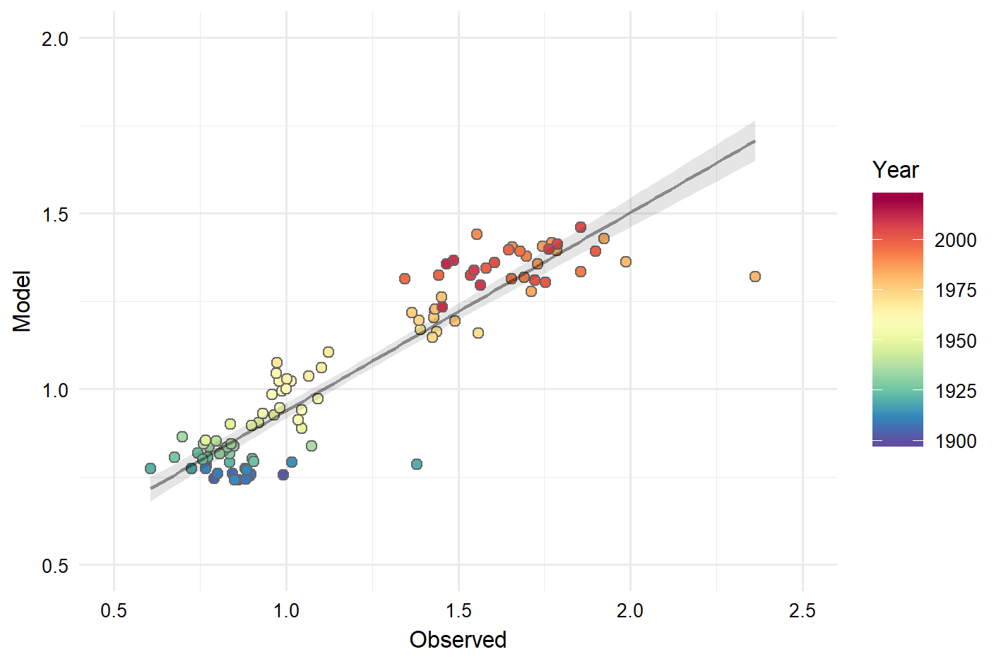

**FIGURE 3**  **Comparison of model-based and observation-based HEAT classifications**. Regression of Baltic average Eutrophication Ratio from BALTSEM model (BSAP30) vs. Eutrophication Ratio based on observations for the period 1901-2012 (y = 0.37 + 0.57 x) R2= 0.85, p < 0.001.

Given the relation in Figure 3, we have carried out integrated assessments of eutrophication status based on 4 different input scenarios all 9 offshore basins (Figure 4, panels 1-1).

In Scenario 4, increasing loads lead to a worsening of the eutrophication status in all basins. In some basins, i.e. the Baltic Proper (Figure 4; panel e) and Gulf of Finland (Figure 4; panel g), ER values can potentially reach 2.5. Scenario 3, with constant loads at reference period levels (1997-2003), the eutrophication status will improve but not the target of a Baltic Sea unaffected by eutrophication. In this scenario, the only basin likely to meet the BSAP objectives with constant loads is Arkona Basin (Figure 4; panel c), though the status in the Kattegat will come close to the objectives (Figure 4, panel a) and

Scenarios 1 and 2 may potentially result in oligotrophication *sensu* Nixon (2009) and thus give a better future eutrophication status in most of the Baltic Sea basins. However, even in these best case scenarios, some basins are still unlikely to attain a good status with ER values below 1.0, i.e. the Gulf of Riga and Bothnian Bay.

Scenarios 1 and 2 results in a good status in 7 out of 9 basins, whereas the Gulf of Riga and the Bothnian Sea seem to be lost causes. For scenario 3, only a single basin, Arkona, attains a good status. Based on the assessment of the individual basins seen in Figure 4, we can identify the year in each basin, where the status improves and ultimately turns into good, defining this as the year in which the ER value falls below 1.0. Since there is some year-to-year variation in ER, we judge that the objective of good status in a basin is met not in the first year with an ER value below 1.0 but when the average over a 10-year period falls below 1.0.

Using this criterion for recovery, scenario 1 predicts that Arkona Basin is the first to achieve good status, in 2024, followed by the Kattegat and Bornholm Basin in 2057, then the Gulf of Finland and Danish Straits in 2064 and 2080, respectively. Good status is achieved in the Baltic Proper and Bothnian Sea around 2200, just within the time scale of the model.

Scenario 2 follows a similar pattern, with basins achieving good status in the same order as scenario 1, though, as might be expected, with delays. Here, good status is achieved in the Arkona Basin in 2033 and in the Danish Straits in 2088. Again, the Baltic Proper and the Bothnian Sea just manage to achieve good status by 2200. As described above, Arkona is the only basin expected to return to a good status in scenario 3. This is predicted to occur in in2079.

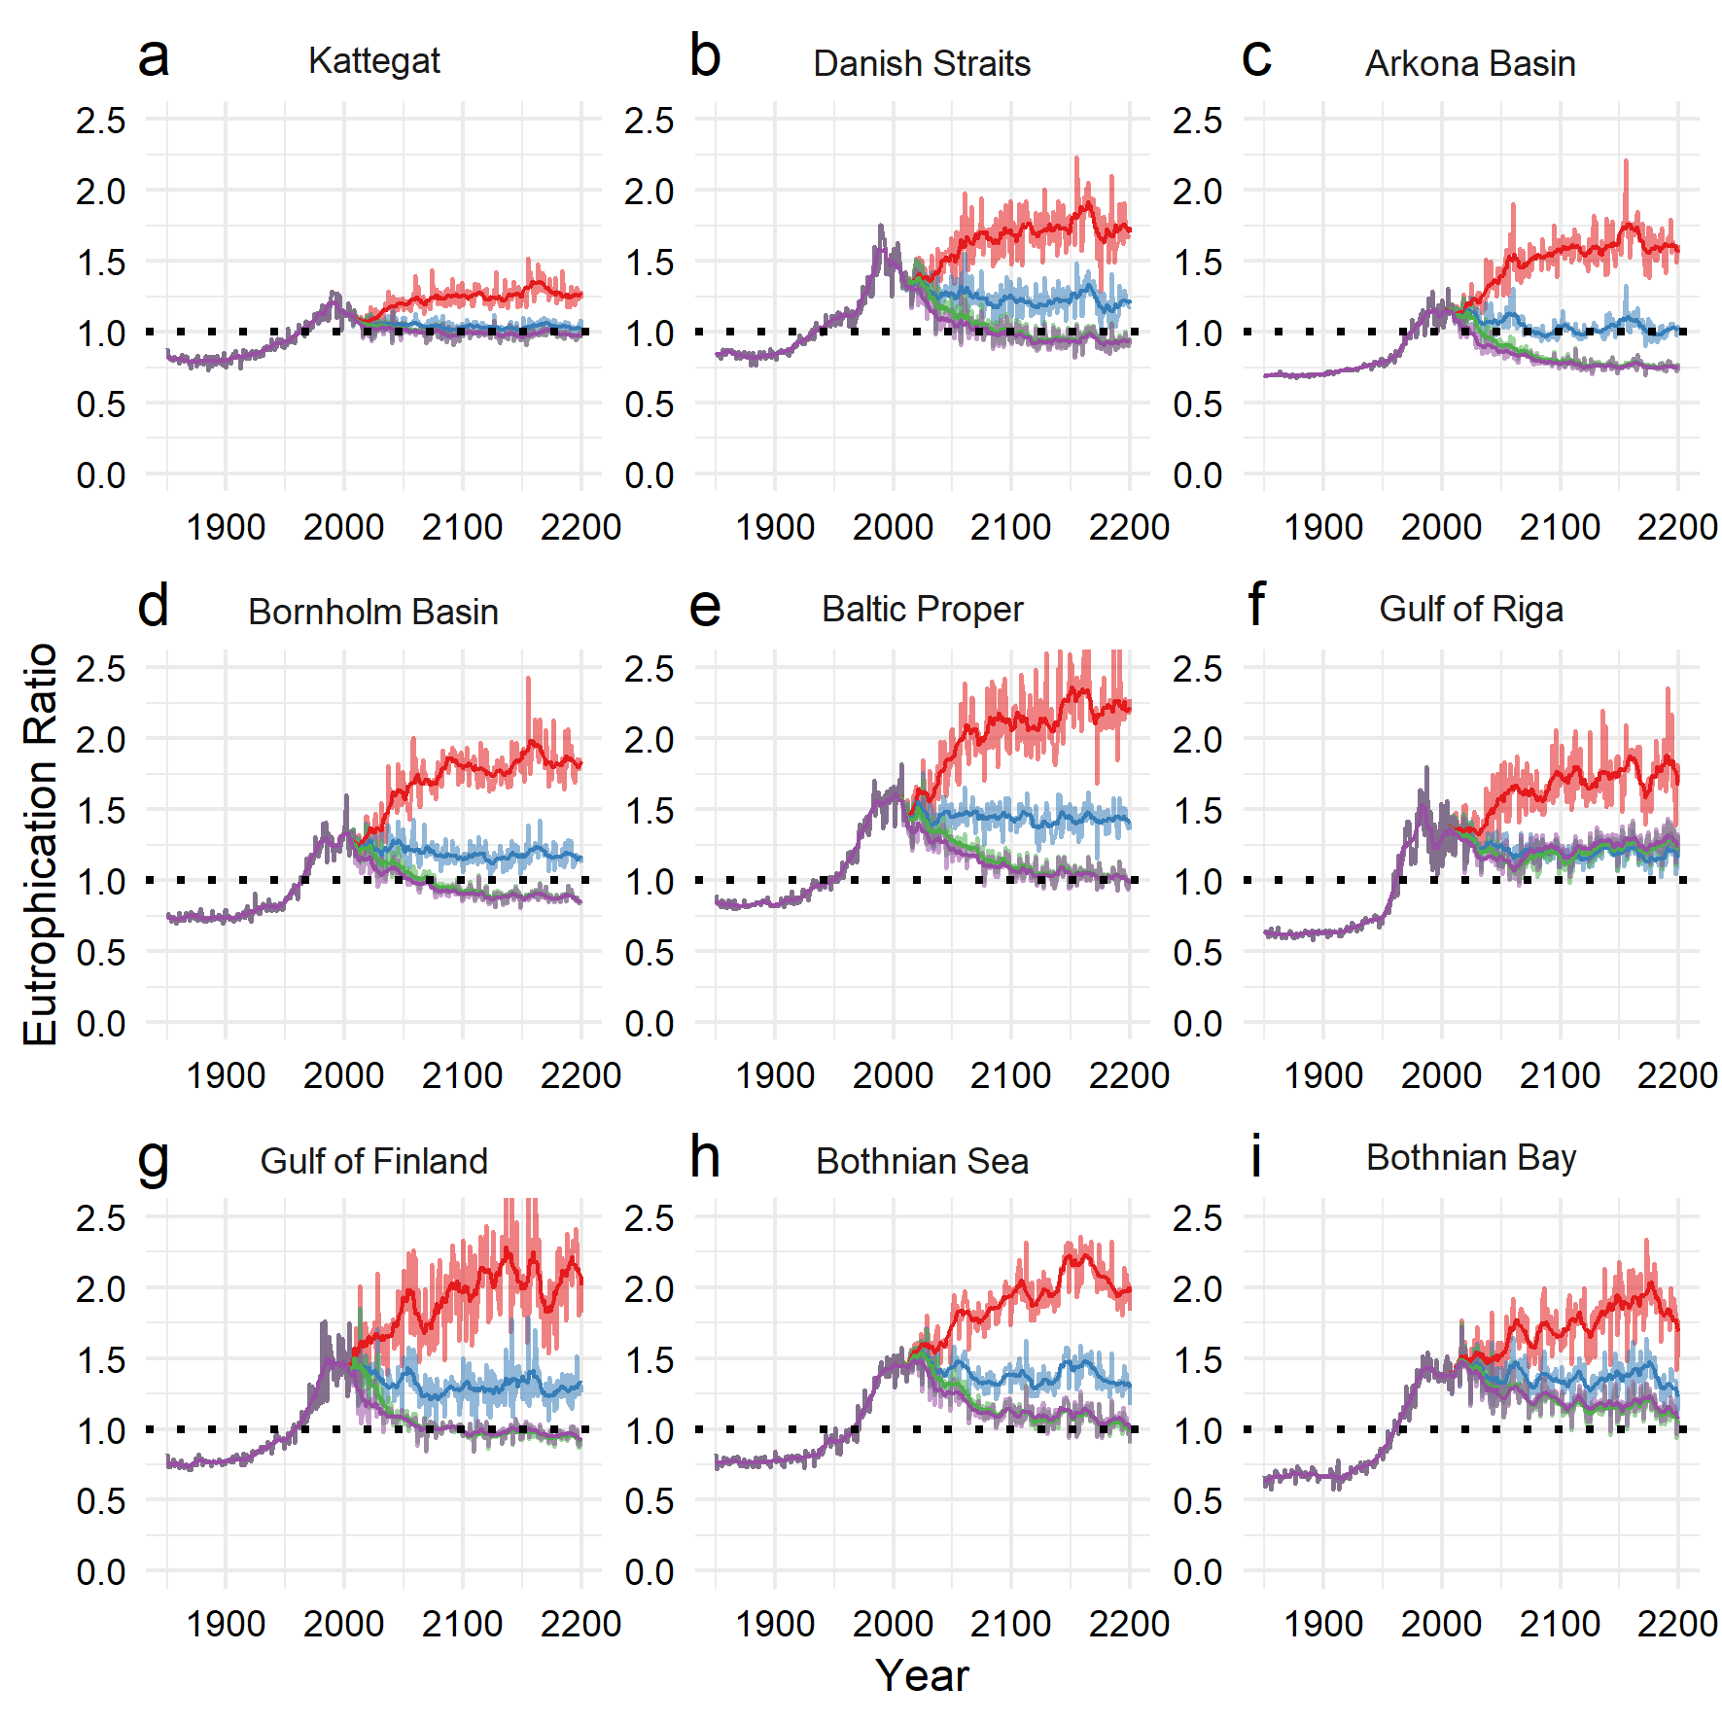

**FIGURE 4** **Model-based HEAT assessment results**. Eutrophication Ratio (ER) from 1850 to 2200 in the 9 Baltic basins are shown for 4 load scenarios (purple: scenario 1, green: scenario 2, blue: scenario 3, red: scenario 4). For each scenario the lighter shaded line shows the annual result and the darker line the 10-year moving average result. The dotted line indicates ER=1.0, the boundary between eutrophic and non-eutrophic status.

**DISCUSSION**

It has previously been documented, at least in terms of nutrient enrichment and eutrophication, that the Baltic Sea has changed from being in a eutrophication phase and has now entered an oligotrophication phase and thus can be said to be in recovery (Andersen et al. 2017). Similarly, many case of oligotrophication and partial recovery have been documented in many coastal waters, e.g. in Denmark (Riemann et al., 2016), in Sweden (xxxxx), in Finland (xxxx) and in xxxxx (xxxxx 20xx).

The relation between observation-based HEAT classifications and model-based HEAT classifications for the period 1902-2012 document a reasonable relation between the two methods of assessing eutrophication status. The model-based HEAT results capture 57% of the variation seen in the observation-based HEAT results but we find that this study’s model-based assessments are justified and in our understanding a meaningful way to assess the potential effects of the BSAP.

In scenarios 1-3, loads will be reduced. Our study show how eutrophication status will improve accordingly – and that patience is needed. In most basins, there are significant gaps between implementation of measures leading to reduced loads and ecological responses. Time lags are well-known and the eutrophication assessments document these expected time-lags.

The current eutrophication status is far from the agreed status and the objectives set up in the BSAP. This is well documented (this study; Andersen et al. 2017; Fleming-Lehtinen et al. 2016). Decision-makers and the wider public may be aware of the current poor situation, but might not know that a state-of-the-art ecosystem-based nutrient management strategy (the BSAP’s eutrophication segment, HELCOM 2007, HELCOM 2013a) has been agreed and need to be fully implemented to attain a Baltic Sea unaffected by eutrophication.

Improving the communication between decision-makers and the scientific society should of course be anchored in scientific studies and literature, but the primary means of communication is not scientific papers and complicated graphs. There is in our opinion a need for simplification, where complex information is synthetized in info-graphics, where the messages can be more easily understood. For example, the information in Figure 3 can be presented as a figures such as Figure 4, where the eutrophication status, and the basins-wise trends are presented using 5 classes. What has happened in the Baltic Sea with respect to eutrophication, and what we can expect to happen in the future is now expressed in colours and the interpretation is straight forward: the status of Baltic Sea has changed over the past 160 years from being unaffected by eutrophication to being affected, and 2) the likely consequence of the agreed load reductions (scenarios 1 and 2), once implemented, will be significant improvements and ultimately a Baltic Sea unaffected by eutrophication, although a few basins will still be affected.

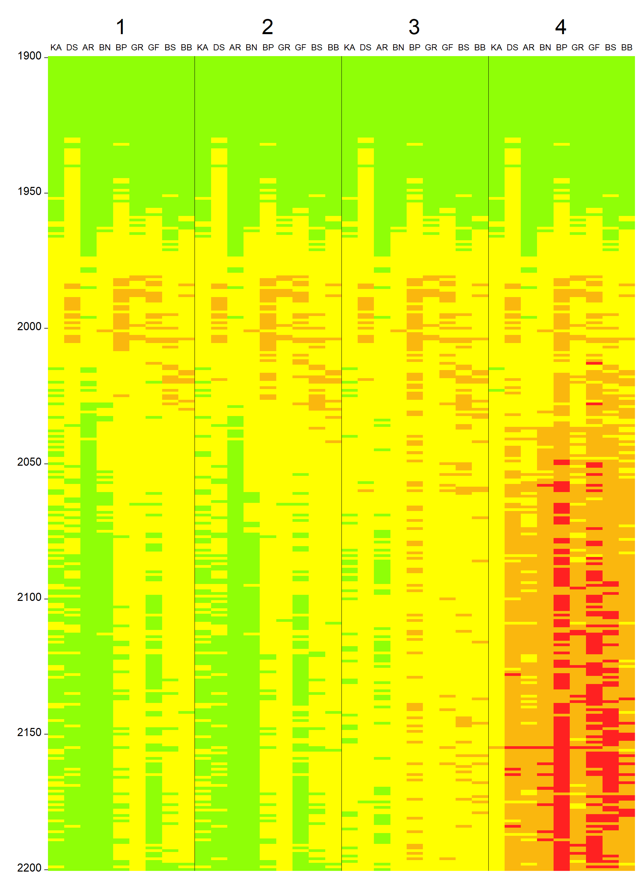

**FIGURE 5 Integrated assessment of eutrophication status the period 1900-2200**. The colours green, yellow, orange, red indicate, respectively, Good, Moderate, Poor or Bad eutrophication status. Basins are indicated by KA: Kattegat, DS: Danish Straits, AR: Arkona Basin, BN: Bornholm Basin, GS: Baltic Proper, GR: Gulf of Riga, GF: Gulf of Finland, BS: Bothnian Sea, BB: Bothnian Bay.

Combining the classifications from the 9 basins into a Baltic Sea-wide assessment has previously been done by Andersen et al. (2017), in this way data for several indicators representing different features of the ecosystem are synthesised into a single value. The results of this study, the eutrophication status classifications based on the 4 scenarios, are presented in a similar manner (Figure 6). The individual basins-wise trends seen in Figure 4 are thus integrated and reflect the overall long-term trends in eutrophication status resulting from differences between nutrient inputs scenarios. This integration supports the interpretation of the classification presented in Figure 5 and reveal, not surprisingly, that scenarios 3 and 4 do not lead to a Baltic Sea unaffected by eutrophication, whilst scenarios 1 and 2 will both, with time, meet the overall objective of a clean and healthy Baltic Sea.

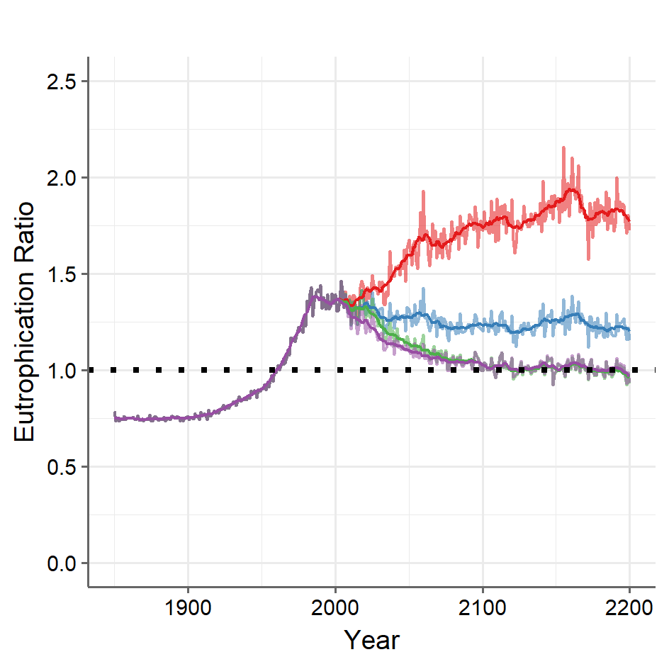

**FIGURE 6** **Integrated Baltic Sea-wide HEAT assessment**. We have combined the 9 basins into a single Batic Sea-wide number. For each scenario, the lighter shaded line shows the annual result and the darker line shows the 10-year moving average result. The dotted line indicates ER=1, the boundary between eutrophic and non-eutrophic status.

The long-term trends in loads, indicators and eutrophication status follow distinctive trajectories for the four scenarios, though the differences between scenarios 1 and 2 narrow continuously. Communicating these things, especially the links between the human activities, the loads to the Baltic Sea, the responses in selected indicators, the time lags and ultimately the overall implication with respect to eutrophication status, to decision makers is important. One of many ways of synthetizing the results of this Baltic Sea-wide study is to compare the trends for selected indicators and for the worst-case (scenario 4) and best-case scenario (scenario 1). By doing so, we illustrate the difference between implementing a state-of-the-art ecosystem-based nutrient management strategy (BSAP) and doing nothing at all (Figure 8).

An interesting finding from the long-term trends is that the biological responses (chl-a, Secchi depth and oxygen debt, the latter a result of biological degradation of organic material) return to a good status with respect to eutrophication earlier than indicators for DIN and DIP concentrations. In other words, considering biological response indicators alone, it is likely that something resembling a Baltic Sea unaffected by eutrophication would be achieved earlier than could be expected when including nutrient concentrations in the assessment.

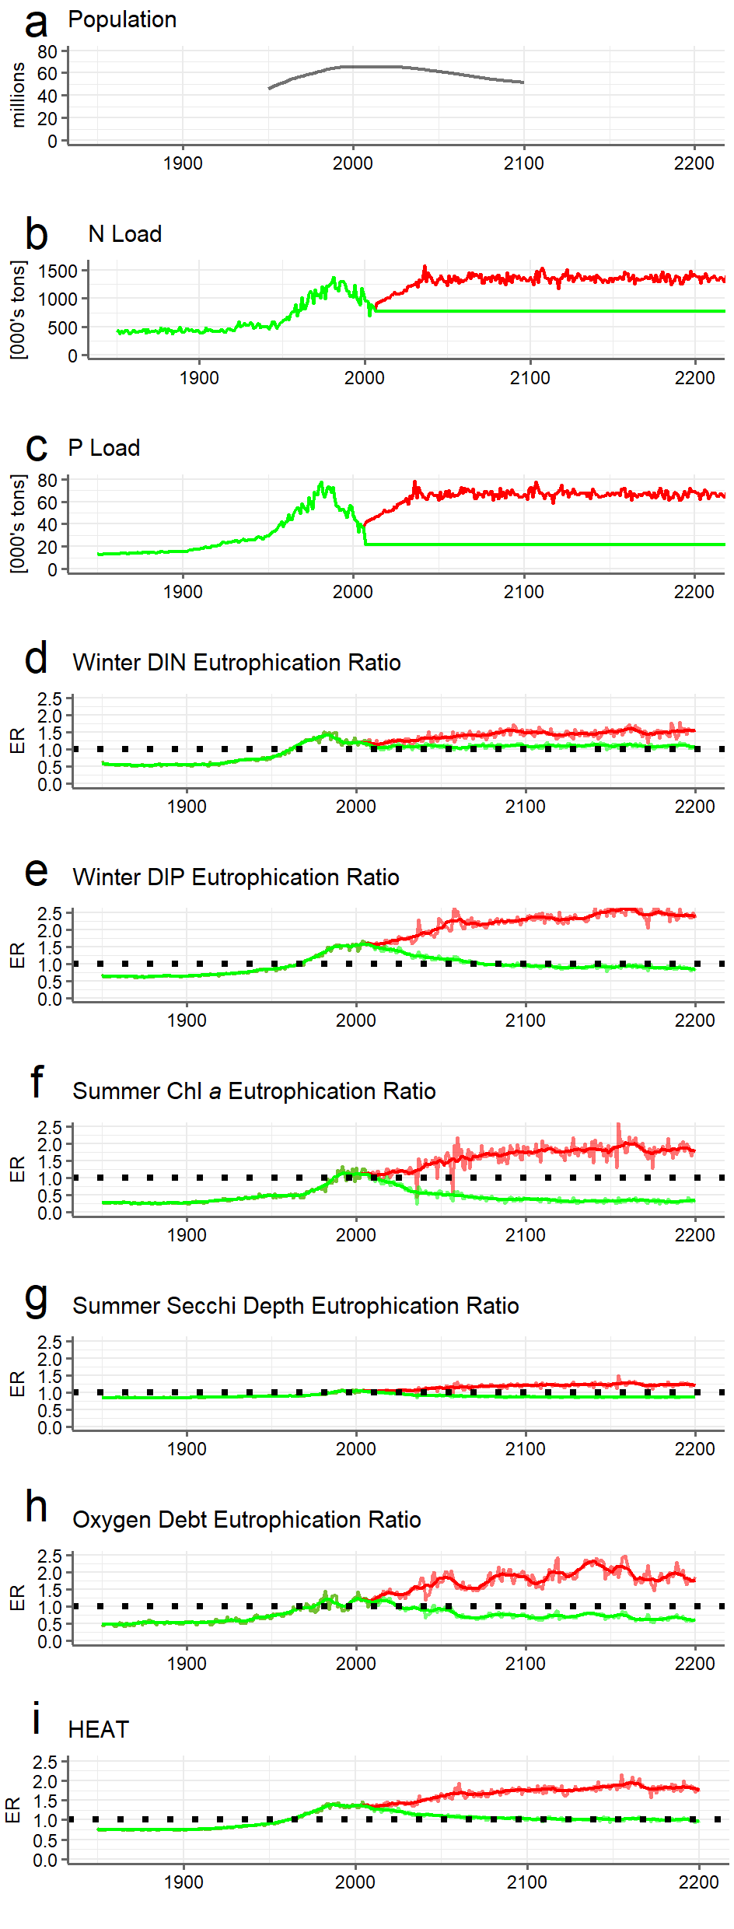

**FIGURE 8** **Long-term temporal trends for the Baltic Sea**. Panel a: UN estimated (1950-2015) and predicted (2015-2100) total population of seven Baltic countries*, panel b-c: total Baltic load of, respectively, N and P, panel d-i: modelled trajectories (worst case: red; best case: green) of average across 9 basins of Eutrophication Ratio 1850-2200 for DIN (panel d), DIP (panel e), Chl-a (panel f), Secchi depth (panel g), and oxygen debt (panel h), and in panel i: the integrated assessment of eutrophication status. For ER, a light line shows annual values and heavy line 10-year moving average. *Denmark, Estonia, Finland, Latvia, Lithuania, Sweden, Poland.

**CONCLUSIONS AND PERSPECTIVES**

The BSAP may according to model predictions be an efficient driver regarding reduction of nutrient loads. However, this requires commitments from all HELCOM Contracting Parties. Without a collective and strong commitment, we risk failing in attaining a Baltic Sea unaffected by eutrophication.

This study illustrates that a good status with respect to eutrophication will be met for most parts of the Baltic Sea. This recovery has already started but the ultimate effects will not be visible soon, but in a much longer perspective. A strength of the study is that it concludes that the overall objective of a clean and healthy Baltic Sea is within reach, but both patience and further load reductions are needed.

An interesting finding is that the indicators representing biological responses do seem to respond faster to load reduction than indicators representing nutrient concentrations. This implies that visually we will attain a good eutrophication far earlier than indicated by the integrated assessment based on the HEAT tool and the full range of indicators. This is positive, but on the contrary, it should be noted that none of the scenarios take climate change, especially elevated sea temperatures into account. Thus, there seems to be an urgent need to include climate change in future updates of the BSAP and to update the projected development in eutrophication status.

**AUTHOR CONTRIBUTIONS**

CM and JHA: conceived the study.

BMK and BG: provided modelled trajectories from the BALTSEM model.

CM: did the calculations.

CM, JHA, BG and BMK: wrote a preliminary version of the manuscript.

All: discussed and reworked the manuscript.

**ACKNOWLEDGEMENTS**

This study, which is dedicated to the memory of Prof. Fredrik Wulff, is a Baltic Nest Institute activity co-funded by Aarhus University (AU) and Stockholm University (SU). Parts of the analyses were funded by EEA ETC ICM 2016 task 161g.

**SUPPLEMENTARY MATERIAL**

Supplementary material associated with this article can be found in the online version, at http://xxxxxxxxx.

**REFERENCES**

Andersen, J.H., Axe, P., Backer, H., Carstensen, J., Claussen, ,U., Fleming-Lehtinen, V., Järvinen, M., Kaartokallio, H., Knuuttila, S., Korpinen, S., Kubiliute, A., Laamanen, M., Lysiak-Pastuszak, E., Martin, G., Møhlenberg, F., Murray, C., Nausch, G., Norkko, A., and Villnäs, A. (2011). Getting the measure of eutrophication in the Baltic Sea: towards improved assessment principles and methods. Biogeochemistry 106, 137-156.

Andersen, J.H., Murray, C., Kaartokallio, H., Axe, P., and Molvær, J. (2010). A simple method for confidence rating of eutrophication status assessments. Marine Pollution Bulletin 60:919-924.

Andersen, J.H., J. Carstensen, D.J. Conley, K. Dromph, V. Fleming-Lehtinen, B. Gustafsson, A. Josefson, A. Norkko, A. Villnäs and Murray, C. (2017). Long-term temporal and spatial trends in eutrophication status of the Baltic Sea. Biological Reviews 92, 135-149.

Anon. (2008). Directive 2008/56/EC of the European Parliament and of the Council of 17 June 2008 establishing a framework for community action in the field of marine environmental policy (Marine Strategy Framework Directive). Official Journal of the European Communities L 164/19.

Arheimer, B., Dahné, J., and Donnelly, C. (2012). Climate change impact on riverine nutrient load and land-based remedial measures of the Baltic Sea Action Plan. Ambio, 41(6), 600-612. doi: 10.1007/s13280-012-0323-0

Backer, H., et al. (2010) HELCOM Baltic Sea Action Plan: A regional programme of measures for the marine environment based on the Ecosystem Approach.Marine Pollution Bulletin 60 (5): 642–649. doi:10.1016/j.marpolbul.2009.11.016

Carstensen, J., Gustavsson, B.G., Andersen, J.H., Conley, D.J. (2014). Deoxygenation of the Baltic Sea during the last century. Proceedings of the National Academy of Science 111(15), 5628-5633.

Conley, D.J. et al. (2011). Hypoxia Is Increasing in the Coastal Zone of the Baltic Sea. Environmental Science & Technology 45(16):6777-83. doi: 10.1021/es201212r

Conley, D.J. (2012). Save the Baltic Sea. Nature 486, 463-464. doi: 10.1038/486463a

Eilola, K., Gustafsson, B.G., Kuznetsov, I., Meier, H.E.M., Neumann, T., Savchuk, O.P. (2011). Evaluation of biogeochemical cycles in an ensemble of three state-of-the-art numerical models of the Baltic Sea. Journal of Marine Systems 88, 267–284. doi:10.1016/j.jmarsys.2011.05.004

Fleming-Lehtinen, V., Andersen, J.H., Carstensen, J., Łysiak-Pastuszak, E., Murray, C., Pyhälä, M., Laamanen, M. (2015). Recent developments in assessment methodology reveal that the Baltic Sea eutrophication problem is expanding. Ecological Indicators 48, 380-388.

Fleming-Lehtinen, V., Laamanen, M. (2012). Long-term changes in Secchi depth and the role of phytoplankton in explaining light attenuation in the Baltic Sea. Estuarine, Coastal & Shelf Science 102, 1-10.

Fleming-Lehtinen, V. (2016) Secchi depth in the Baltic Sea – an indicator of eutrophication. PhD dissertation, University of Helsinki. Retrieved from <https://helda.helsinki.fi/bitstream/handle/10138/168525/Secchide.pdf>

Gustafsson, B.G., Blenckner, T., Eilola, K., Mackenzie, B., Meier, H. E. M., Müller-Karulis, B., Neumann, T., Niiranen, S., Rhoija-Airola, T., Savchuk, O., Schenk, F., Tomczak, M., Zorita, E. (2012). Reconstructing the development of Baltic Sea eutrophication 1850-2000. AMBIO 41, 534-548.

Gustafsson, B.G., Schenk, F., Blenckner, T., Eilola, K., Meier, H.E.M., Muller-Karulis, B., Neumann, T., Ruoho-Airola, T., Savchuk, O.P., and Zorita, E. (2012). Reconstructing the Development of Baltic Sea Eutrophication 1850–2006. Ambio 41, 534-548. doi:10.1007/s13280-012-0318-x

Hägg, H. E., Lyon, S. W., Wällstedt, T., Mörth, C.-M., Claremar, B., and Humborg, C. (2014). Future Nutrient Load Scenarios for the Baltic Sea Due to Climate and Lifestyle Changes. AMBIO 43: 337. doi:10.1007/s13280-013-0416-4

HELCOM (2007). HELCOM Baltic Sea Action Plan. Helsinki Commission, 103 pp.

HELCOM (2009). Eutrophication in the Baltic Sea. An integrated thematic assessment of eutrophication in the Baltic Sea region. Baltic Sea Environmental Proceedings No. 115B. Helsinki Commission, 148 pp.

HELCOM (2010). Ecosystem Health of the Baltic Sea. HELCOM Initial Holistic Assessment 2003-2007. Baltic Sea Environment Proceedings 122, 63 pp.

HELCOM (2013a). HELCOM Copenhagen Ministerial Declaration.

HELCOM (2013b). Approaches and methods for eutrophication target setting in the Baltic Sea region. Baltic Sea Environment Proceedings 133, 147 pp. Retrieved via: <http://www.helcom.fi/Lists/Publications/BSEP133.pdf>.

HELCOM (2013c). Review of the Fifth Baltic Sea Pollution Load Compilation for the 2013 HELCOM Ministerial Meeting. Baltic Sea Environment Proceedings 141, 54 pp. Retrieved via <http://helcom.fi/Lists/Publications/BSEP141.pdf>

HELCOM (2014). Eutrophication status of the Baltic Sea 2007–2011 – a concise thematic assessment. Baltic Sea Environmental Proceedings 143, 40 pp. Retrieved via: <http://www.helcom.fi/Lists/Publications/BSEP143.pdf>.

Köster, F. W., Hinrichsen, H., St. John, M. A., Schnack, D., MacKenzie, B. R., Tomkiewicz, J., and Plikshs, M. (2001). Developing Baltic cod recruitment models. II. Incorporation of environmental variability and species interaction. Canadian Journal of Fisheries and Aquatic Sciences 58(8), 1534-1556.

MacKenzie, B. R., Hinrichsen, H., Plikshs, M., Wieland, K., and Zezera, A. S. (2000). Quantifying environmental heterogeneity: Habitat size necessary for successful development of cod gadus morhua eggs in the Baltic Sea. Marine Ecology Progress Series, 193, 143-156.

Meier, H. E. M., Andersson, H. C., Eilola, K., Gustafsson, B. G., Kuznetsov, I., Müller-Karulis, B., Neumann, T., Savchuk, O.P. (2011). Hypoxia in future climates: A model ensemble study for the Baltic Sea. Geophysical Research Letters 38(24). doi:10.1029/2011GL049929

Meier, H.E.M., Muller-Karulis, B., Andersson, H.C., Dieterich, C., Eilola, K., Gustafsson, B.G., Höglund, A., Hordoir, R., Kuznetsov, I., Neumann, T., Ranjbar, Z., Savchuk, O.P., and Schimanke, S. (2012). Impact of Climate Change on Ecological Quality Indicators and Biogeochemical Fluxes in the Baltic Sea: A Multi-Model Ensemble Study. *Ambio* 41, 558-573. doi:10.1007/s13280-012-0320-3

Meier et al. (2018). Disentangling the impact of nutrient load and climate changes on Baltic Sea hypoxia and eutrophication since 1850 Climate Dynamics. doi: 10.1007/s00382-018-4296-y

Neumann, T., Eilola, K., Gustafsson, B., Muller-Karulis, B., Kuznetsov, I., Meier, H.E.M., Savchuk, O.P., (2012). Extremes of Temperature, Oxygen and Blooms in the Baltic Sea in a Changing Climate. Ambio 41, 574-585. doi:10.1007/s13280-012-0321-2

Nixon, S.W. (2009) Eutrophication and the macroscope. Hydrobiologia 629: 5. doi:10.1007/s10750-009-9759-z

Richardson, K. and Heilmann, J. P. (1995) .Primary production in the Kattegat: Past and Present. Ophelia 41(1):317-328. Doi:10.1080/00785236.1995.10422050

Riemann, B., J. Carstensen, K. Dahl, H. Fossing, J.W. Hansen, H.H. Jakobsen, A.B. Josefson, D. Krause-Jensen, S. Markager, P. Stæhr, K. Timmerman, J. Windolf, J, and Andersen, J.H. (2016). Recovery of Danish coastal ecosystems after reductions in nutrient loading: trends and time lags. *Estuaries & Coasts* 39(1), 82-97.

Savchuk, O.P., Gustafson, B.G., and Muller-Karulis, B. (2012). BALTSEM - a marine model for decision support within the Baltic Sea Region (No. Technical Report No. 7). Baltic Nest Institute.

Schernewski, G., and Neumann, T. (2005). The trophic state of the Baltic Sea a century ago. Journal of Marine Systems 53, 109-124.

Schneider, B., and Kuss, J. (2004). Past and present productivity of the Baltic Sea as inferred from pCO2 data, Continental Shelf Research 24(15), 1611-1622.

Vahtera, E., D.J. Conley, B. G. Gustafsson, H. Kuosa, H.i Pitkänen, O. P. Savchuk, T. Tamminen, M. Viitasalo, M. Voss, N. Wasmund, and F. Wulff (2007). Internal Ecosystem Feedbacks Enhance Nitrogen-fixing Cyanobacteria Blooms and Complicate Management in the Baltic Sea. AMBIO 36(2), 186-194.

Villnäs, A., and Norkko, A. (2011). Benthic diversity gradients and shifting baselines: implications for assessing environmental status. Ecological Applications 21(6), 2172-2186.

Wasmund, N., Göbel, J., v. Bodungen, B. (2008) 100-years-changes in the phytoplankton community of Kiel Bight (Baltic Sea) Journal of Marine Systems 73 (3-4): 300-322. doi:10.1016/j.jmarsys.2006.09.009

Wulff, F., Savchuk, O.P., Sokolov, A., Humborg, C., and Mörth, C.-M. (2007). Assessing the past and the possible future of the Baltic*. AMBIO* 36, 243-249.

**TABLES**

**FIGURES**

**SUPPLEMENTARY MATERIAL**

**Content of the Supplementary Material:**

* **S1: Winter DIN. Scenarios 1-4.**
* **S2:**
* **S3:**
* **S4:**
* **S5:**
* **S6:**
* **S7:**
* **S8:**
* **S9:**
* **S10:**

**S1: Winter DIN. Scenarios 1-4.**

BALTSEM results by basin from 1850 to 2200 for 4 load scenarios (purple: BSAP, green: BSAP 30, blue: PLC55, red: BAU30).

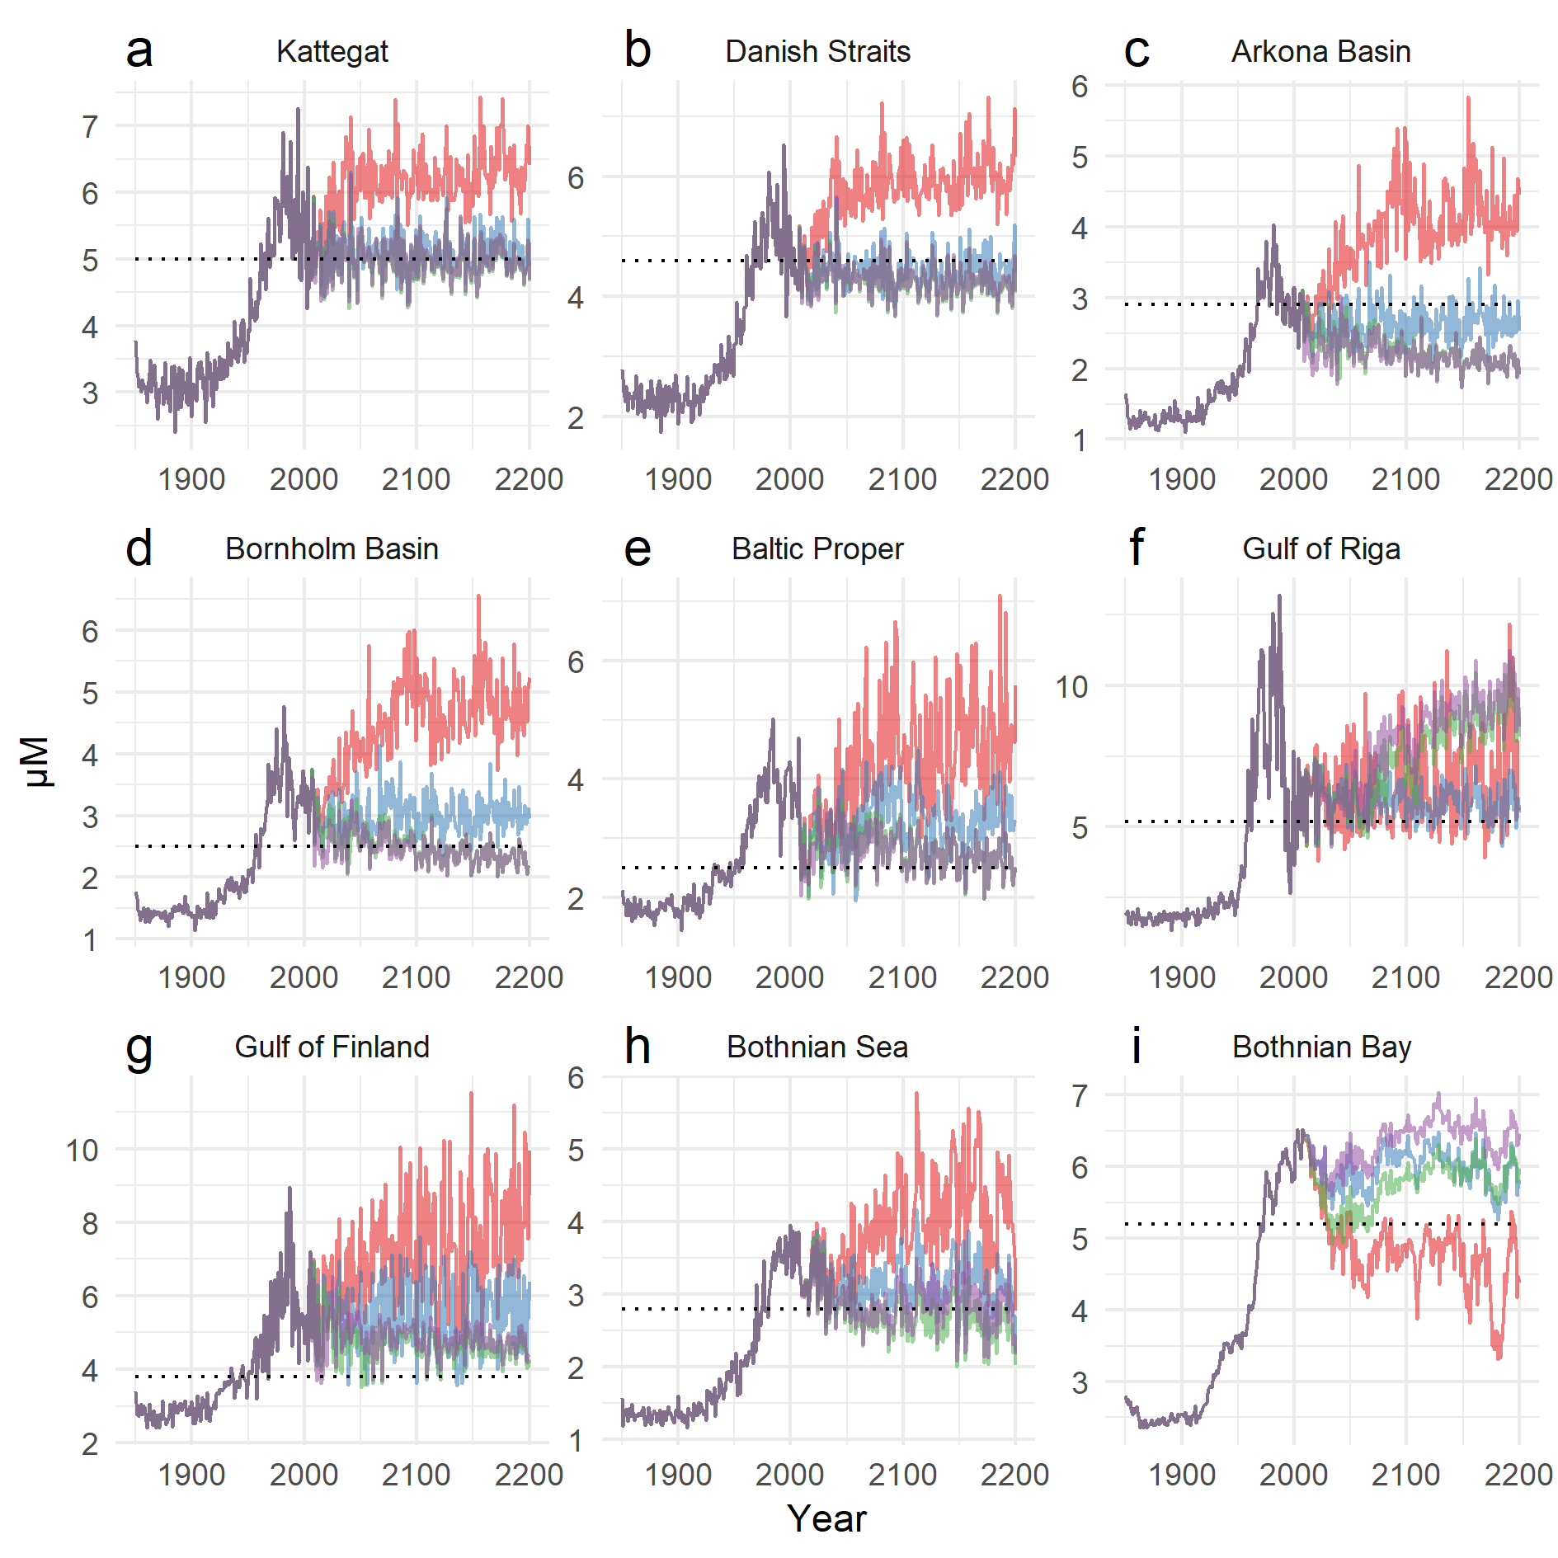

**S2: Winter DIP. Scenarios 1-4.**

BALTSEM results by basin from 1850 to 2200 for 4 load scenarios (purple: BSAP, green: BSAP 30, blue: PLC55, red: BAU30). The dotted line indicates the basin-specific target value used in the HEAT assessment calculations.

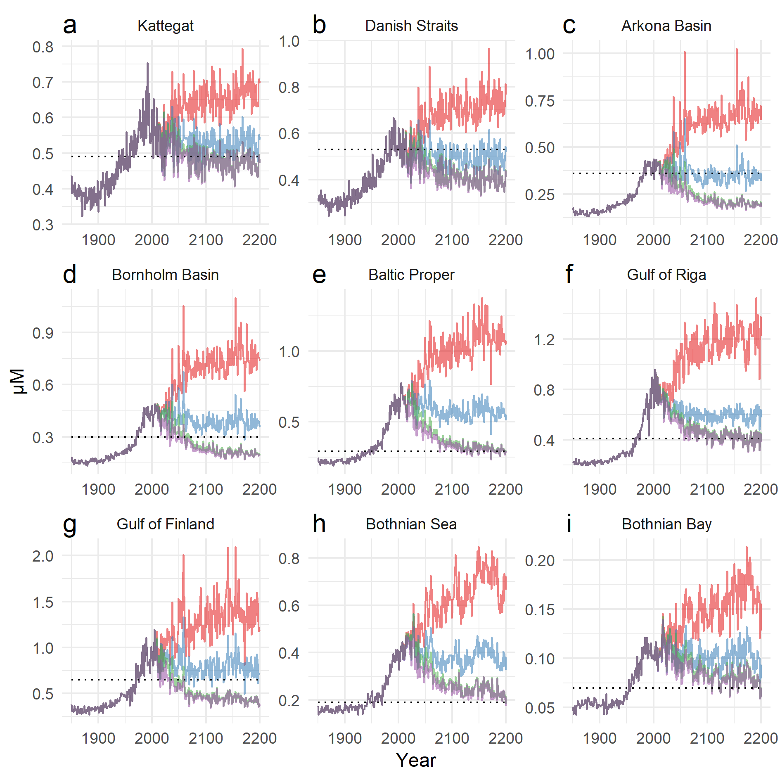

**S3: Summer Chl a. Scenarios 1-4.**

BALTSEM results by basin from 1850 to 2200 for 4 load scenarios (purple: BSAP, green: BSAP 30, blue: PLC55, red: BAU30). The dotted line indicates the basin-specific target value used in the HEAT assessment calculations.

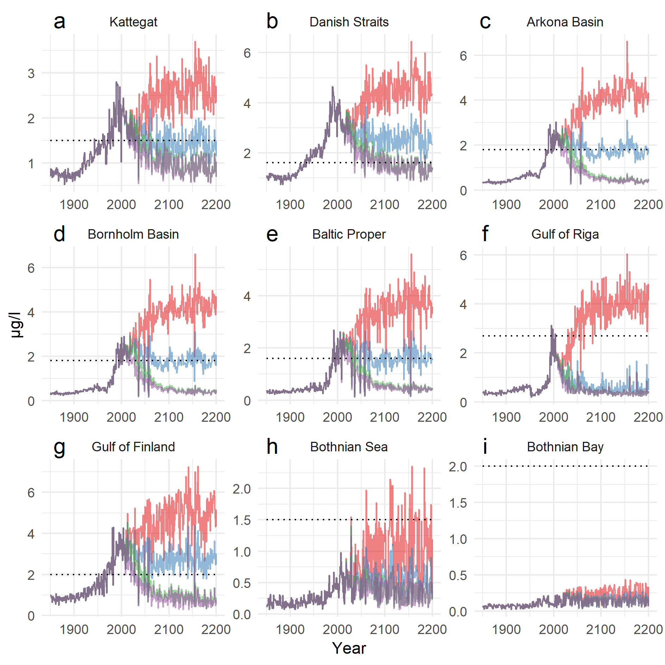

**S4: Secchi depth. Scenarios 1-4.**

BALTSEM results by basin from 1850 to 2200 for 4 load scenarios (purple: BSAP, green: BSAP 30, blue: PLC55, red: BAU30). The dotted line indicates the basin-specific target value used in the HEAT assessment calculations.

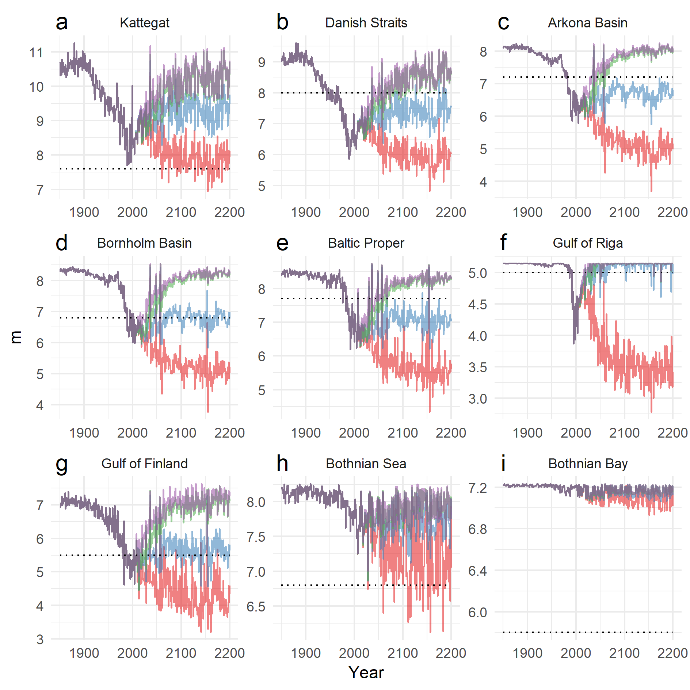

**S5: Oxygen debt. Scenarios 1-4.**

BALTSEM results by basin from 1850 to 2200 for 4 load scenarios (purple: BSAP, green: BSAP 30, blue: PLC55, red: BAU30). The dotted line indicates the basin-specific target value used in the HEAT assessment calculations.

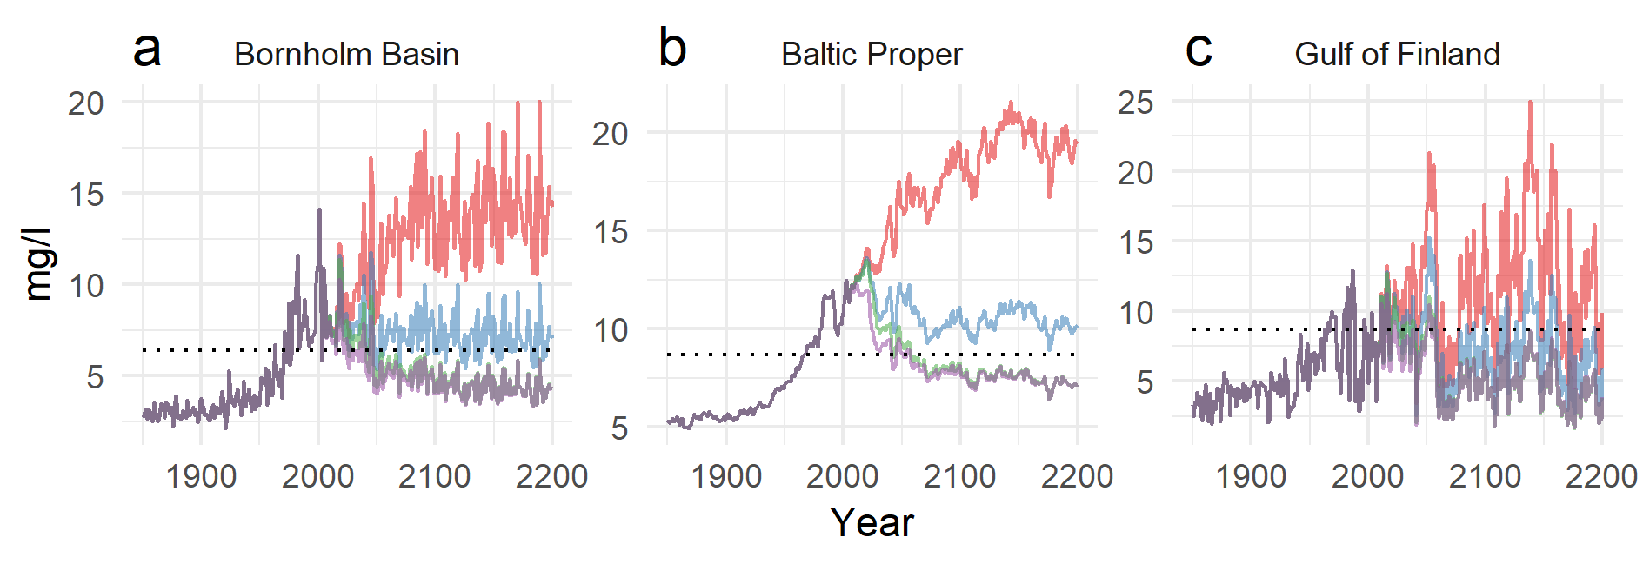

**S6: Winter DIN. Upper panel: Timeseries BALTSEM (BSAP) vs. observations (Andersen et al. 2017). Lower panel: Regression of BALTSEM (BSAP) vs. observations.**

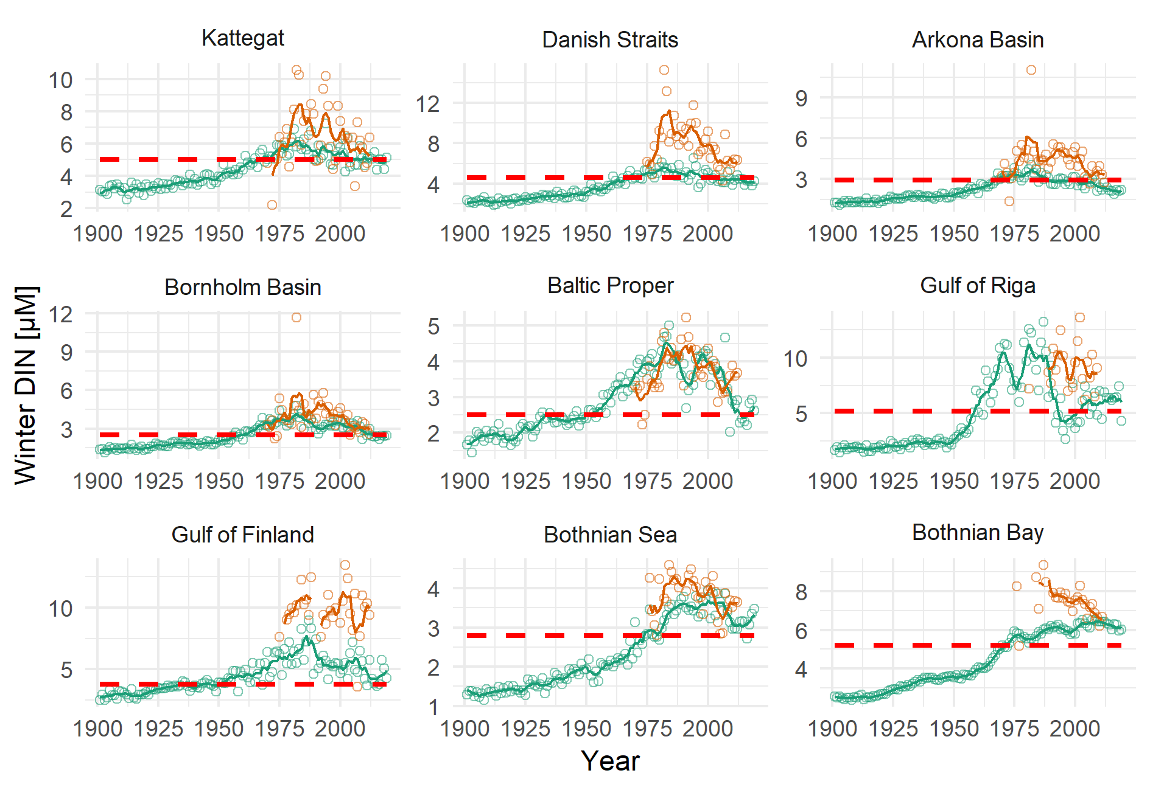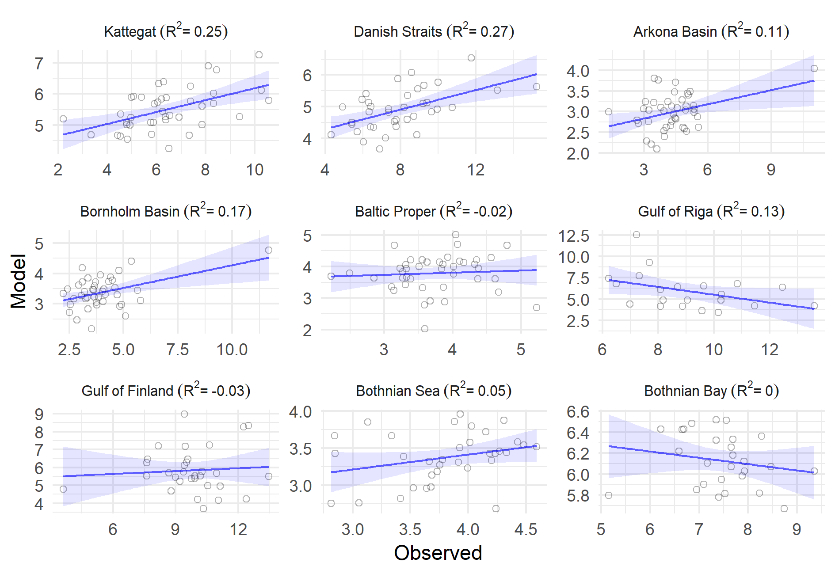

**S7: Winter DIP. Upper panel: Timeseries BALTSEM (BSAP) vs. observations (Andersen et al. 2017). Lower panel: Regression of BALTSEM (BSAP) vs. observations.**

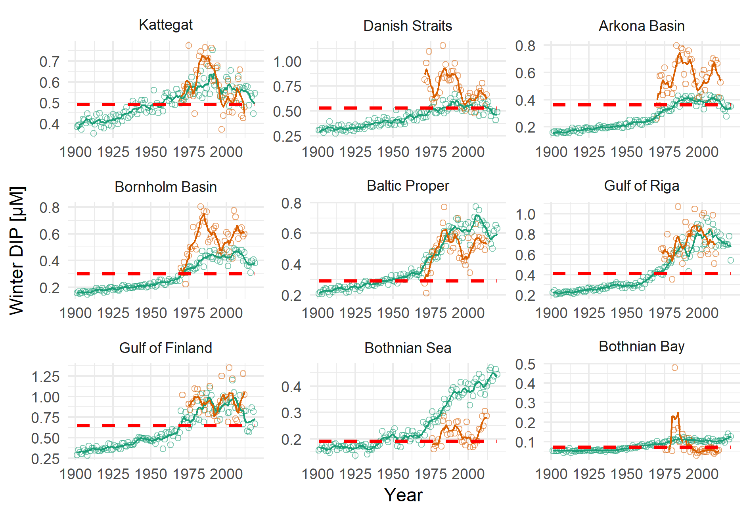

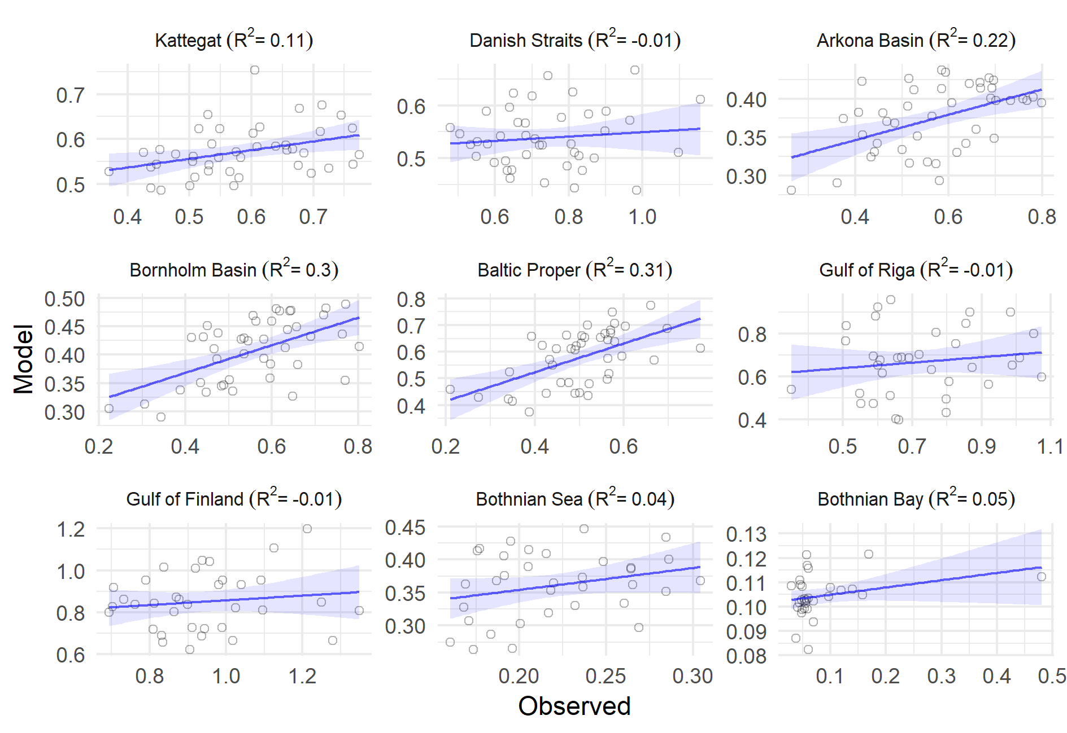

**S8: Summer Chl a. Upper panel: Timeseries BALTSEM (BSAP) vs. observations (Andersen et al. 2017). Lower panel: Regression of BALTSEM (BSAP) vs. observations.**

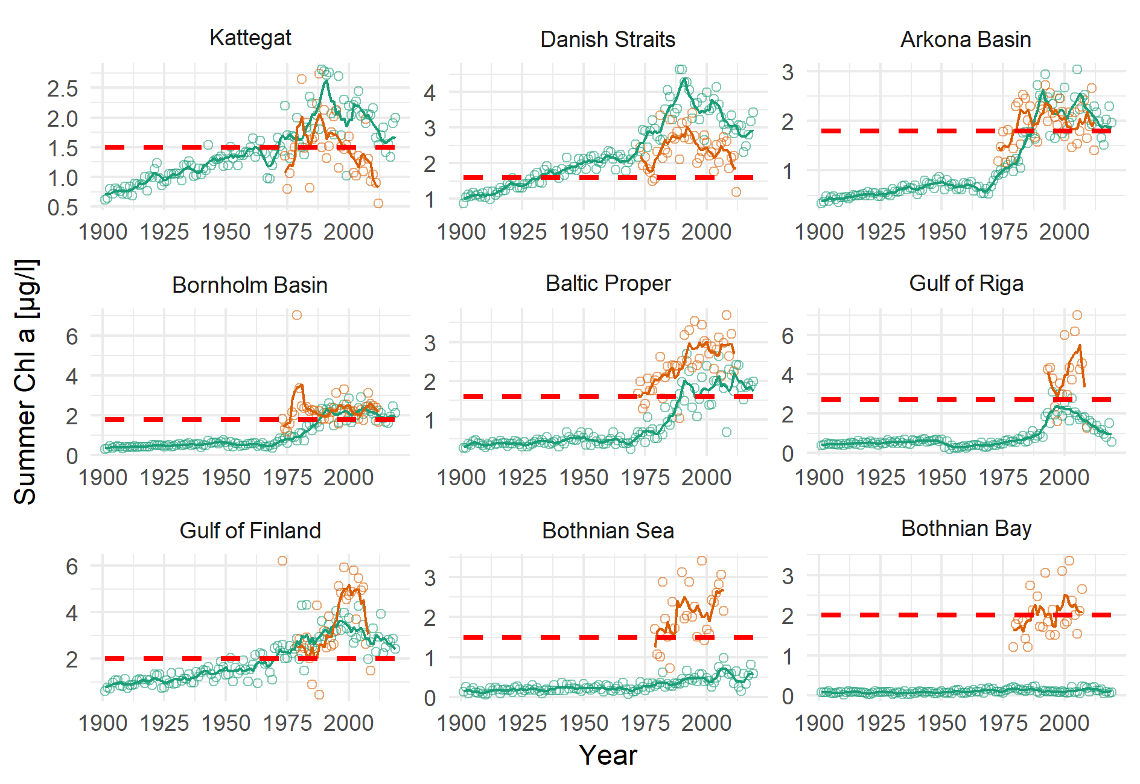

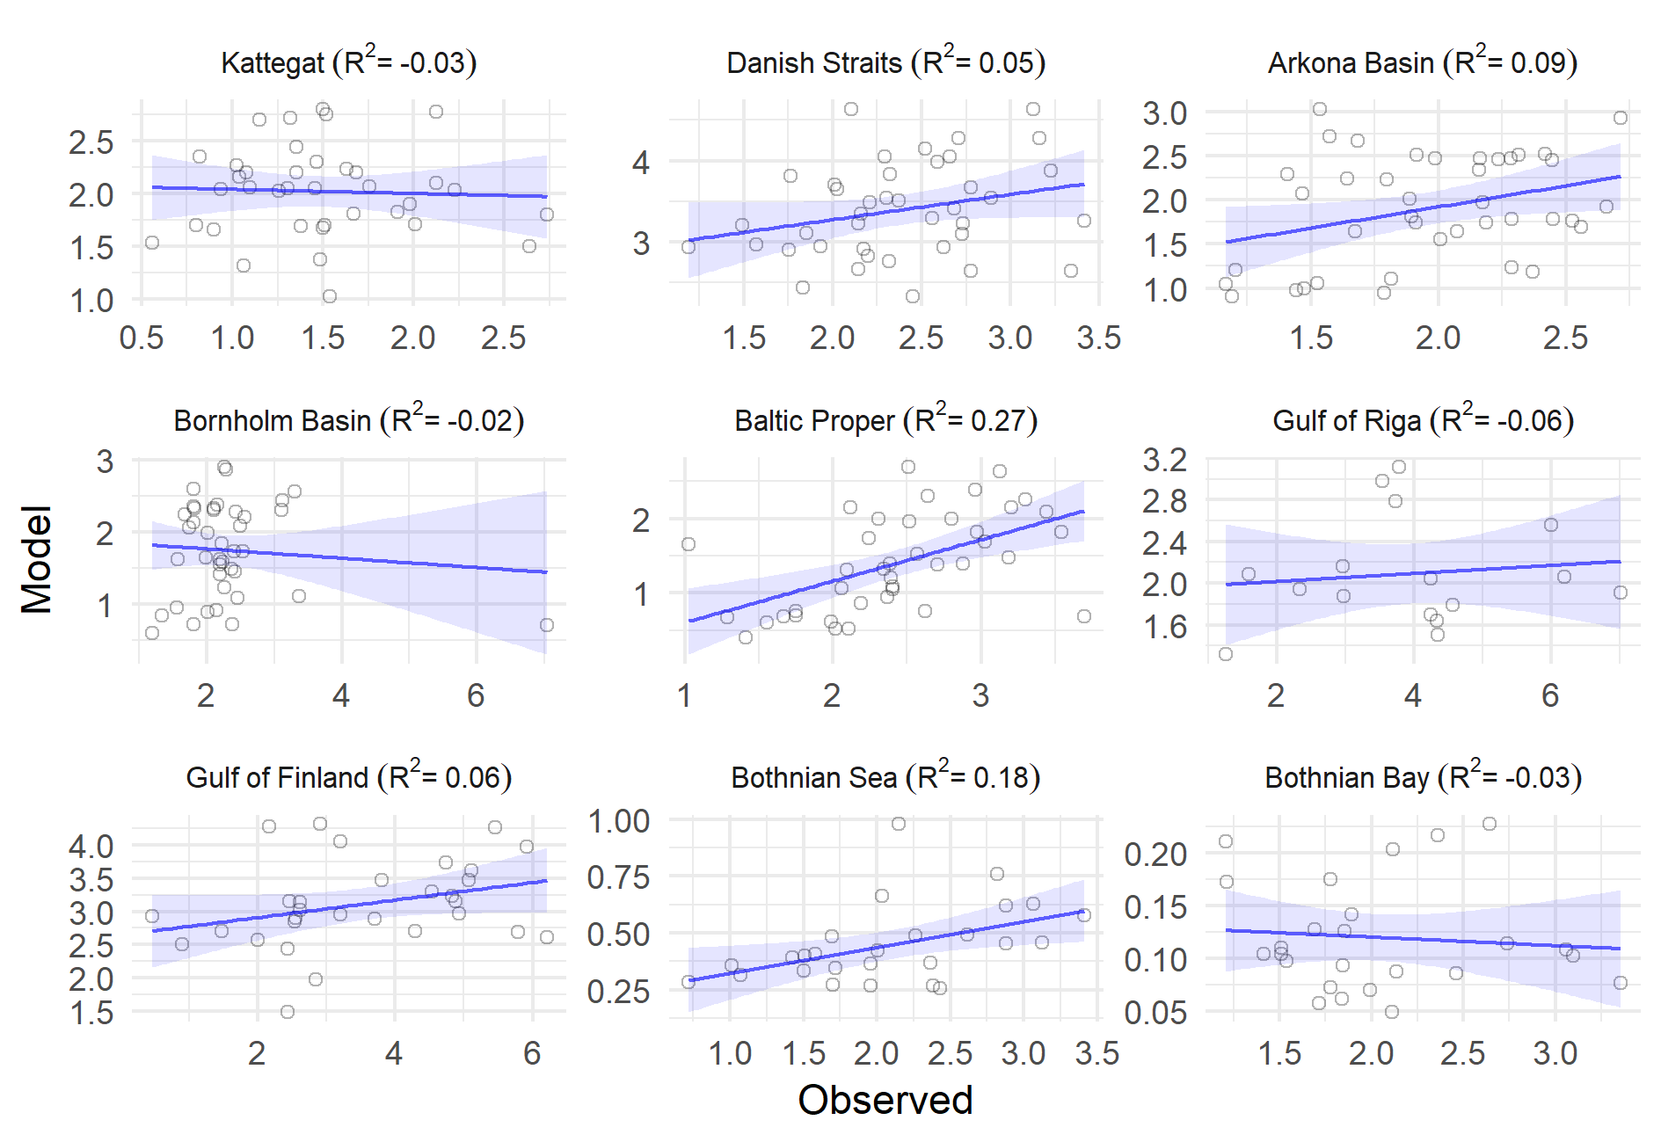

**S9: Secchi depth. Upper panel: Timeseries BALTSEM (BSAP) vs. observations (Andersen et al. 2017). Lower panel: Regression of BALTSEM (BSAP) vs. observations.**

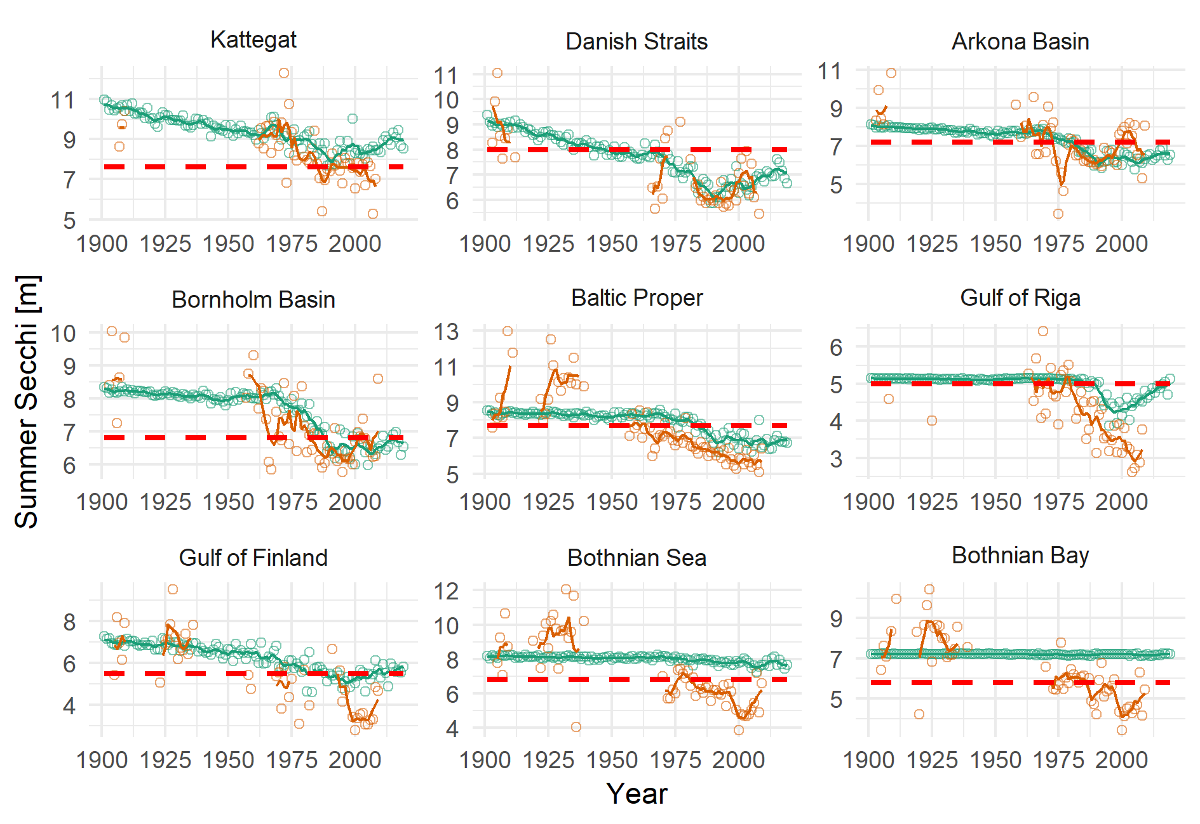

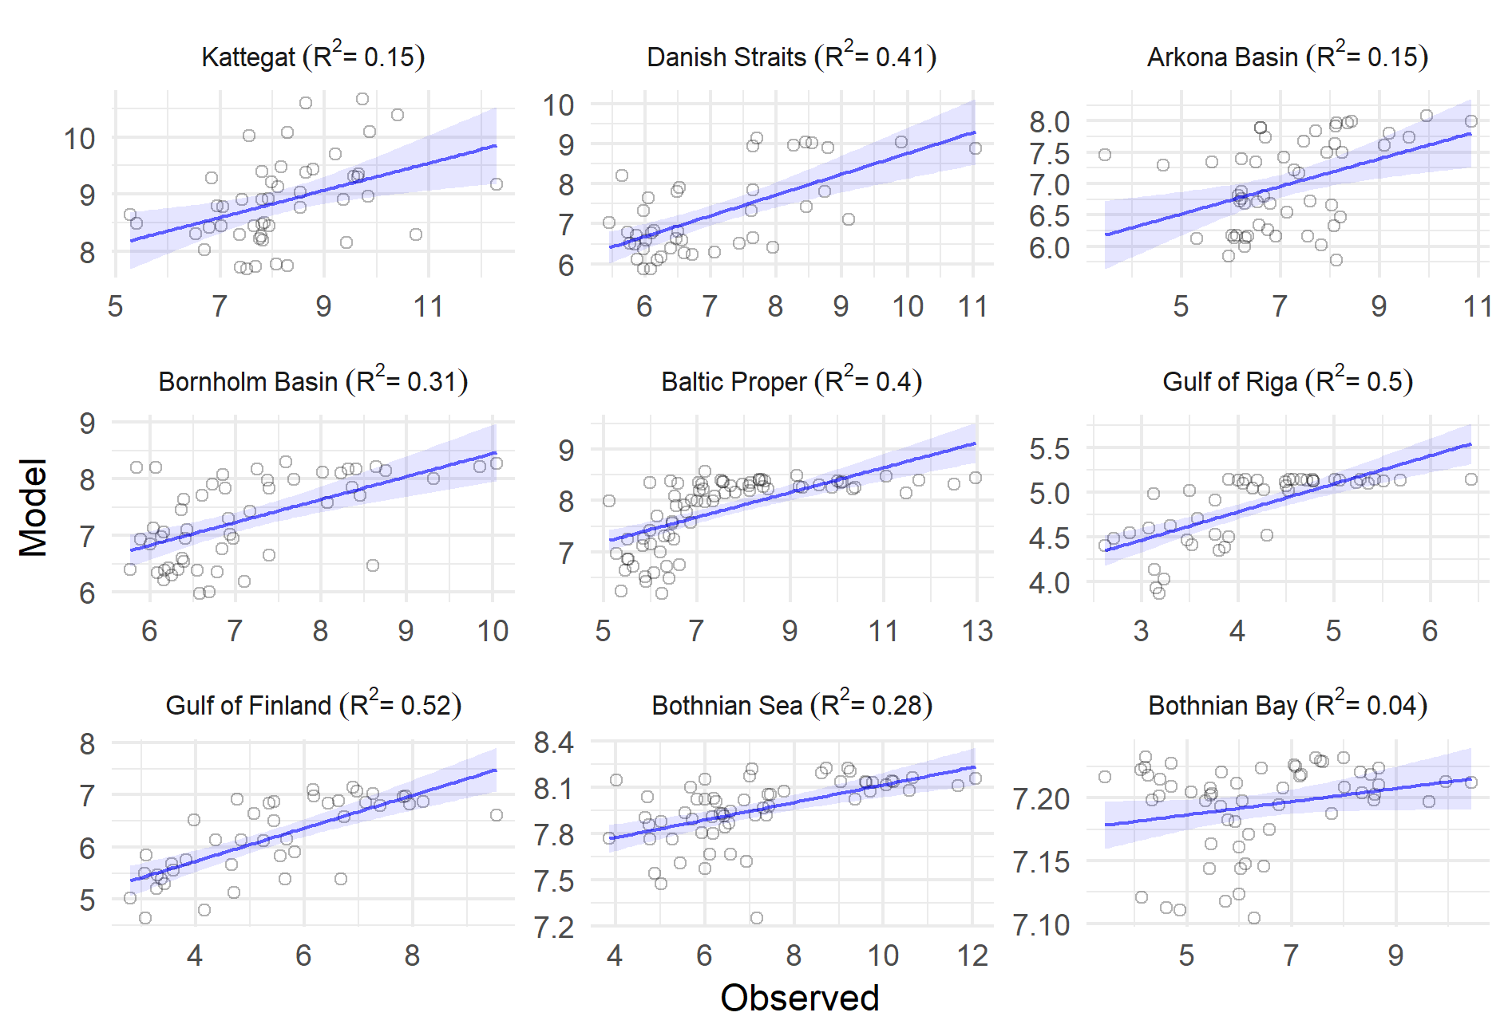

**S10: Oxygen debt. Upper panel: Timeseries BALTSEM (BSAP) vs. observations (Andersen et al. 2017). Lower panel: Regression of BALTSEM (BSAP) vs. observations.**

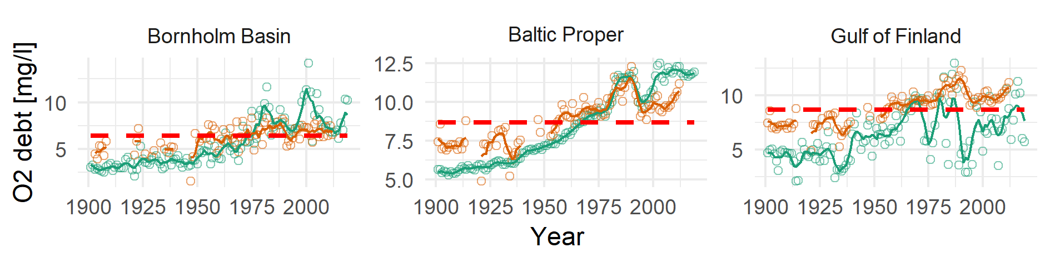

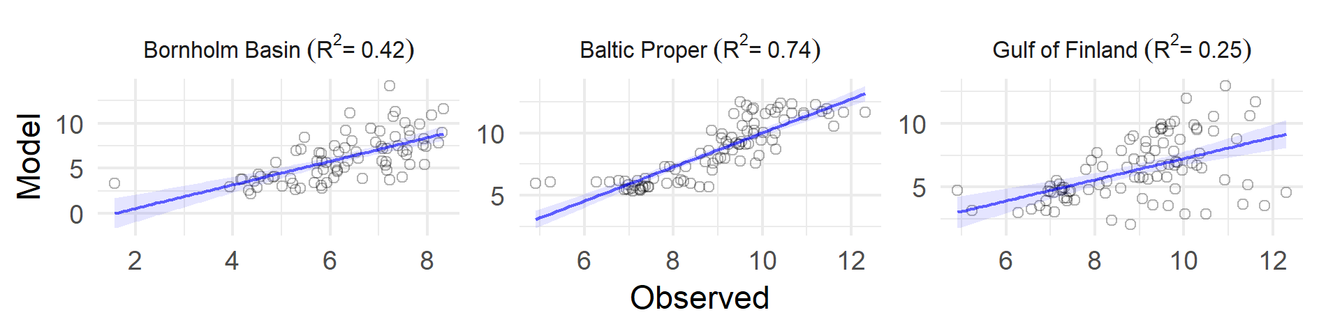

**POTENTIAL REVIEWERS**

1. Morten Skogen (morten.skogen@hi.no)
2. Norbert Wasmund (norbert.wasmund@io-warnemuende.de)
3. Thomas Neumann (thomas.neumann@io-warnemuende.de)
4. Gerald Schernewski (gerald.schernewski@io-warnemuende.de)
5. Markus Meyer (markus.meier@io-warnemuende.de)